**Temple Inn & Suites Site Plan**

**Site Purpose**: To be a place for those who are far from home traveling doing the Lord’s work. To house missionaries, care for families and give opportunities to be close to the temple for other events and services.

**Target Audience**: Full Time Temple Missionaries who will need lodging while they work in the temples, family and friends of brides and grooms, adults and youth who travel far to attend the temple to do ordinances.

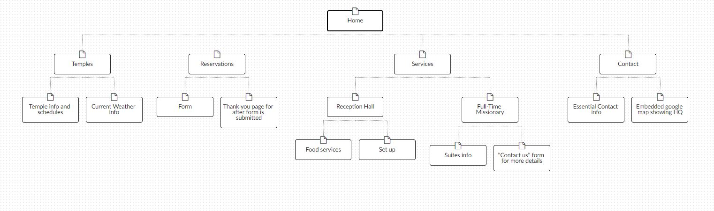**Site map**:

**Color Scheme**:



HEX: #0D5477

HEX: #116F9E

HEX: #093951

HEX: #199BDD

HEX: #106691



HEX: #595959

HEX: #FFFFFF

HEX: #d8d8d8

HEX: #000000

**Typography** Google Fonts:

Headers: Poppins

Body: Playfair Display

Title: Cinzel

**Wireframe Sketches**:

LARGE SCREENS:

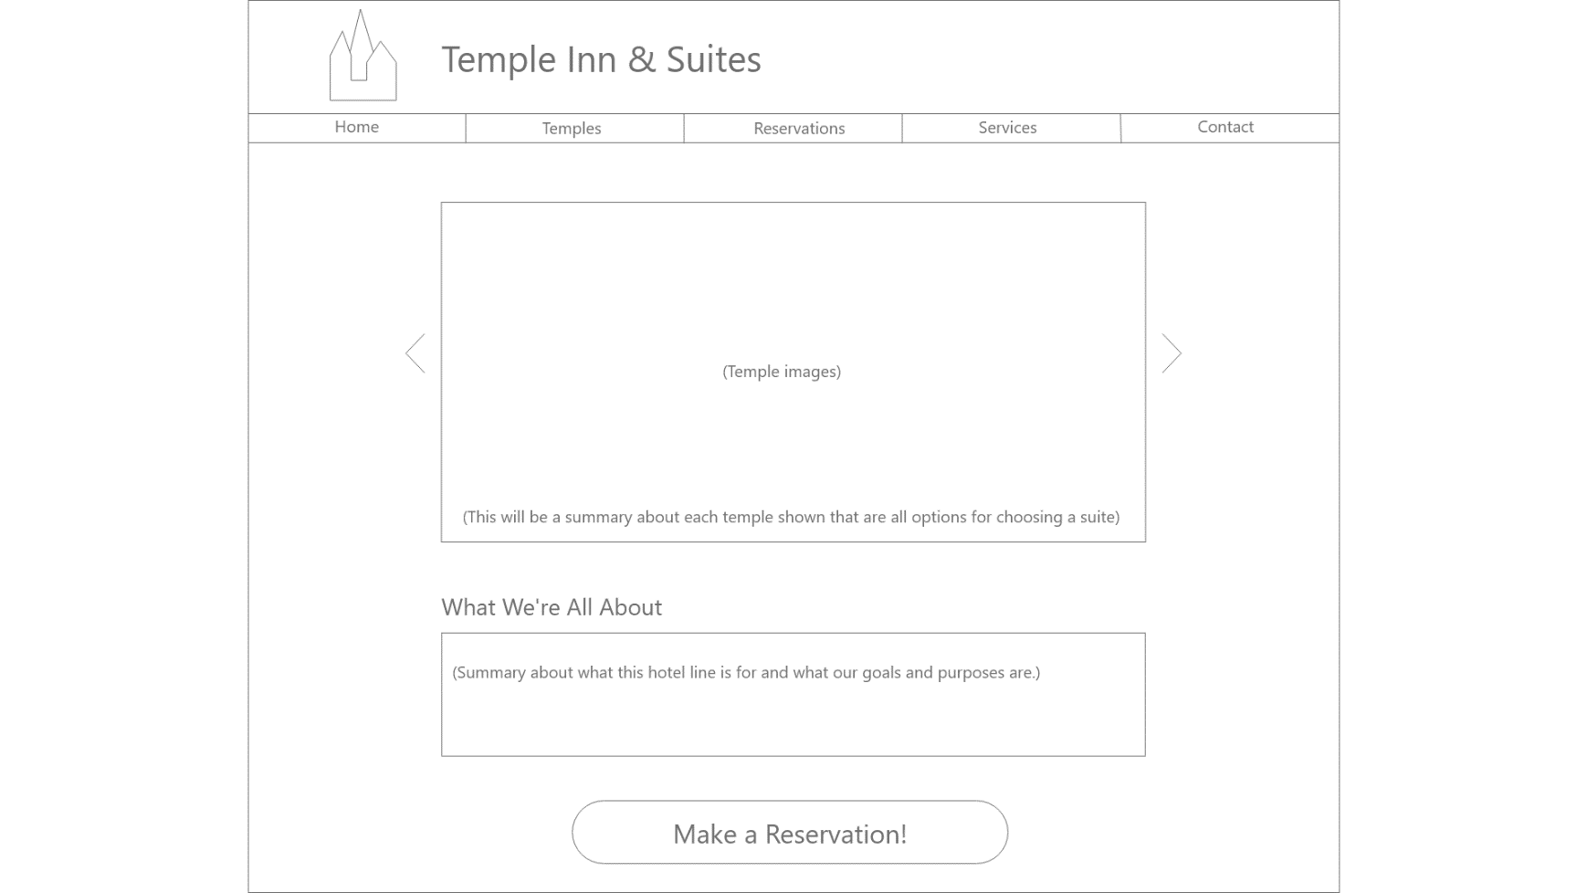

MEDIUM SCREENS:

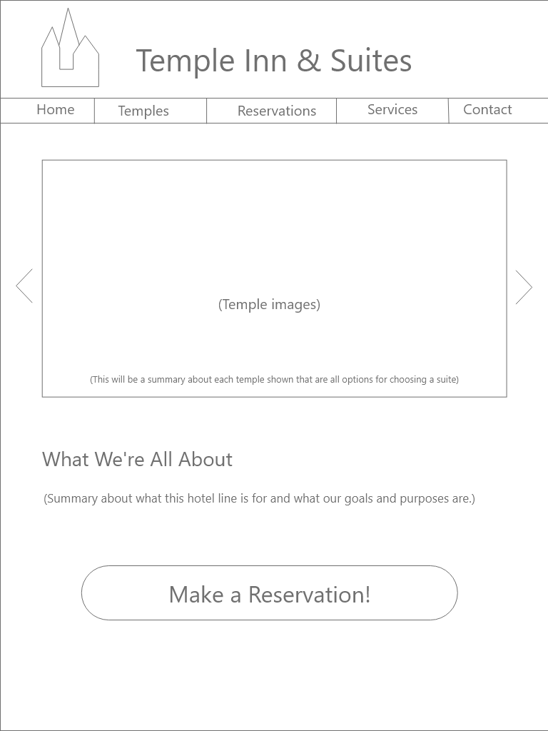

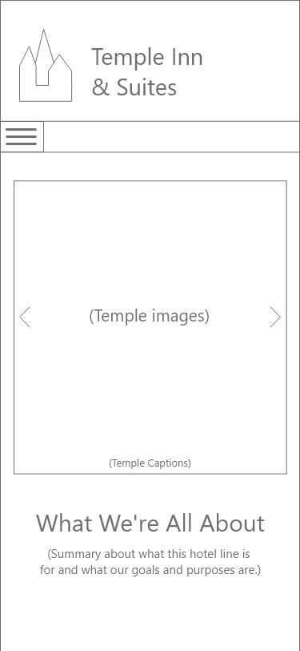SMALL SCREENS: